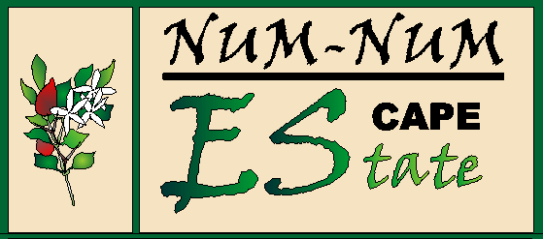**Num-Num HEV (B/3 2022)**

**C/O Status Mark**

**Posbus567**

**Mossel Bay**

**6500**

**ADDENDUM TO THE CONSTITUTION AND RELATED DOCUMENTS OF NUM-NUM HOA**

I ____________________________________________________ the potential owner or mandated representative of the potential owner (if a company or trust, the trustee/director’s resolution to accompany this form) of erf number _______________________ acknowledge that I have read and understood the Constitution and all addendums to same.

The following has specifically been brought to my attention:

1) I am aware of the “footprint” of 900m² and the fact that I may not disturb the plants outside

my footprint.

2) No dogs or cats are allowed on the Estate.

3) Only indigenous plants may be planted (see approved plant list), no kikuyu grass may be planted.

4) Speed limit is 30kph.

5) You are responsible for all your visitors and contractors to your property.

6) Issues on other completed properties do not give you permission to be non-compliant to the rules.

7) Please take note regarding the rules for fencing.

8) There are rules and addendums that relate to the current finalized houses that should be read in conjunction with the constitution.

9) The property was sold by…………………………………………Estate agent………………………………..………Agency.

Signed at __________________________ on this ______ day of __________________ 20___

_________________________________Signature of the potential owner or mandated representative

______________________________________ Signature of a Num Num Trustee